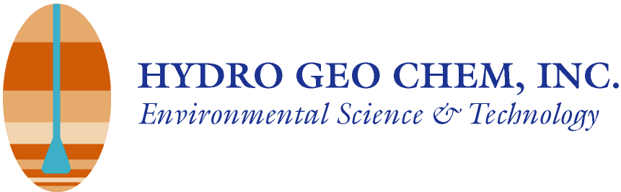
Memo
To: Brice Zeller
From: James Peck, P.E.
Date: June 7, 2010
Re: South Yuma County Landfill – Liquid Waste Acceptance Criteria
This memorandum is provided to summarize South Yuma County Landfill’s (SYCL’s) waste acceptance criteria for accepting liquid wastes for SYCL’s liquids solidification process
Regulatory Requirements
SYCL is authorized to receive non-hazardous liquid wastes for disposal at its liquid solidification process facility as a component of the facility’s approved Solid Waste Facility Plan (approved plan). SYCL is not licensed to accept hazardous waste as defined by the U.S. EPA in 40 CFR 261 and ADEQ in ARS 49-921, radioactive waste subject to the Atomic Energy Act of 1954, polychlorinated biphenyl (PCB) waste, or used oil waste. To be acceptable, any liquid waste must not exhibit a hazardous waste characteristic (ignitability corrosivity, reactivity, or toxicity) and must not be a listed hazardous waste from any source identified in 40 CFR 261 Subpart D. It is the generator’s responsibility to evaluate the waste and to determine whether or not the waste generated is a listed or characteristic hazardous waste prior to disposal.
The approved plan distinguishes liquid wastes from industrial sources and liquid wastes from other sources (including septic or sewage wastes, grease trap wastes, waste from concrete and rock saw cuttings, and human consumables such as off-spec beverage products or rinsate from product lines. .
South Yuma County Landfill Permits
The SYCL is a municipal solid waste disposal facility operating under an approved Solid Waste Facility Plan, ADEQ approval No. 50366100.02, as amended January 15, 2010. The Solid Waste Facility Plan includes provisions for the acceptance and disposal of non-hazardous liquid waste using the facility’s liquid solidification process.
Waste Acceptance Criteria
SYCL requires liquid waste generators to submit a waste profile for approval prior to acceptance of any liquid waste for disposal. The waste profile form must document the type of waste, confirm that the waste is not a listed or characteristic hazardous waste, and provide representative physical/chemical characteristics of the waste. Liquid wastes that classify as either a listed or characteristic hazardous waste under U.S. EPA hazardous waste classification criteria are not acceptable at the SYCL.
Analytical data is required for all liquid wastes from industrial sources. At a minimum the generator must provide analytical data regarding the pH of the waste, volatile organic compound concentrations in the waste by EPA Method 8260B and total metals content for the RCRA 8 metals (silver, arsenic, barium, cadmium, chromium, mercury, lead, and selenium). Additional tests may be required by SYCL depending on the source and nature of the waste. It is important that liquid waste generators provide a detailed description of the process that generated the liquid waste so that appropriate analytical requirements for profiling can be assessed by SYCL.
The waste profile must be updated at least annually with representative characterization information with analytical results from samples collected for analytical parameters that SYCL may request. However, waste profiles for liquid wastes from industrial must be updated once every quarter for the first year of acceptance, and updated annually thereafter.
Waste septage haulers must provide SYCL with current documentation demonstrating that they are licensed by ADEQ for the transport of domestic sewage.
All liquid waste haulers must check in at the scale house prior to discharging any liquid wastes. SYCL may, at its discretion, request a sample of the liquid waste for field screening tests prior to discharging. All liquid wastes must conform to an existing waste profile on file with SYCL to be accepted for disposal. Liquid waste haulers may proceed to the discharge area once approval is obtained from SYCL. Haulers are to discharge to a specific location as directed by SYCL personnel. Additional samples may be collected by SYCL at the time of discharge for independent laboratory analysis. Liquid waste haulers will be held responsible for any waste removal and remediation of disposal trenches resulting from the discharge of unauthorized wastes at SYCL.
SYCL’s liquid waste disposal operation is dependent on the ability of soils in the disposal trench to naturally dry following the discharge of liquid wastes. SYCL may elect to not accept liquid wastes for disposal during significant rain events. No liquids will be accepted for disposal in the liquid solidification trenches during any 24-hour period in which greater than 0.5 inches of precipitation is predicted by the U.S. Weather Bureau.

